Module 5 – DBMS – ER Model

What is DBMS?
A Database Management System (DBMS) is software that helps store, manage, and retrieve data in a structured way.
Examples of DBMS: MySQL, Oracle, Microsoft SQL Server.
Imagine DBMS as a digital cabinet where data is stored in an organized manner so we can find and use it easily.

What is the ER Model?
ER Model stands for Entity-Relationship Model. It is a way to design and visualize the structure of a database before creating it.
It helps show:
- What data needs to be stored
- How different pieces of data are related
This model is usually represented using diagrams called ER diagrams.

Why Use the ER Model?
- Helps design a clear plan for the database
- Makes the structure easy to understand
- Ensures that relationships between data are correctly represented
- Helps avoid errors when building the database

Components of the ER Model

1. Entity
An entity is any real-world object or thing that we want to store data about.
Example: Student, Teacher, Book, Car
In ER diagrams, entities are shown as rectangles.

2. Attributes
Attributes are the properties or characteristics of an entity.
Example: For a Student entity, attributes could be:
- Roll Number
- Name
- Age
- Email
In ER diagrams, attributes are shown as ellipses (ovals) connected to entities.

3. Entity Set
An entity set is a collection of similar types of entities.
Example: All students in a school form the "Student" entity set.

4. Relationship
A relationship is an association between two or more entities.
Example: A student ENROLLS in a course.
In ER diagrams, relationships are shown as diamonds.

5. Relationship Set
A relationship set is a collection of similar types of relationships.
Example: All students who enroll in courses form the ENROLLS relationship set.

6. Keys
A key is an attribute that uniquely identifies an entity.
Example: Student ID can be used to uniquely identify each student.

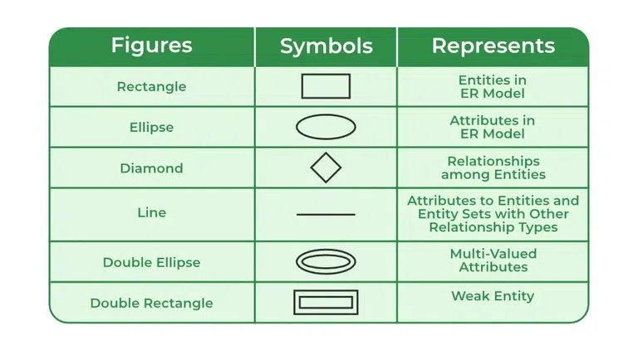

7. Types of Attributes:

Type | Description | Example
Simple | Cannot be divided further | Name
Composite | Can be divided into sub-parts | Name → First Name, Last Name
Derived | Can be calculated from other attributes | Age (calculated from Date of Birth)
Multivalued | Can have more than one value | Phone Numbers

Types of Attributes

1. Key Attribute
The attribute which uniquely identifies each entity in the entity set is called the key attribute. For example, Roll_No will be unique for each student. In ER diagram, the key attribute is represented by an oval with an underline.
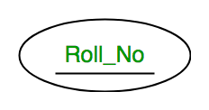

2. Composite Attribute
An attribute composed of many other attributes is called a composite attribute. For example, the Address attribute of the student Entity type consists of Street, City, State, and Country. In ER diagram, the composite attribute is represented by an oval comprising of ovals.
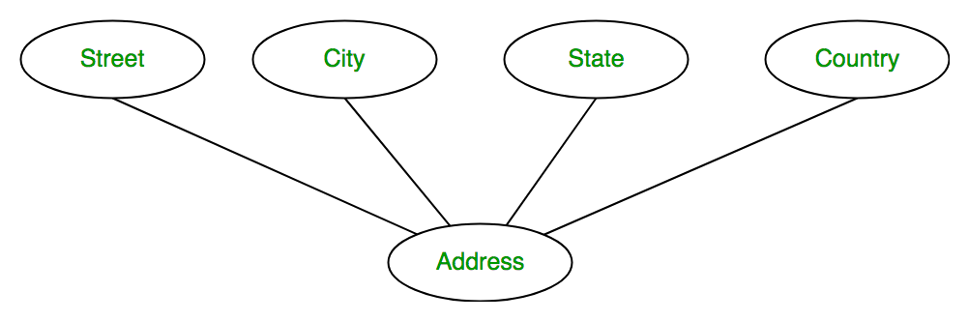

3. Multivalued Attribute
An attribute consisting of more than one value for a given entity. For example, Phone_No (can be more than one for a given student). In ER diagram, a multivalued attribute is represented by a double oval.

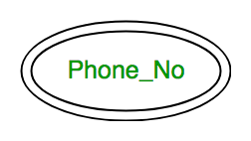

4. Derived Attribute
An attribute that can be derived from other attributes of the entity type is known as a derived attribute. e.g.; Age (can be derived from DOB). In ER diagram, the derived attribute is represented by a dashed oval.
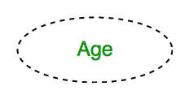

The Complete Entity Type Student with its Attributes can be represented as:

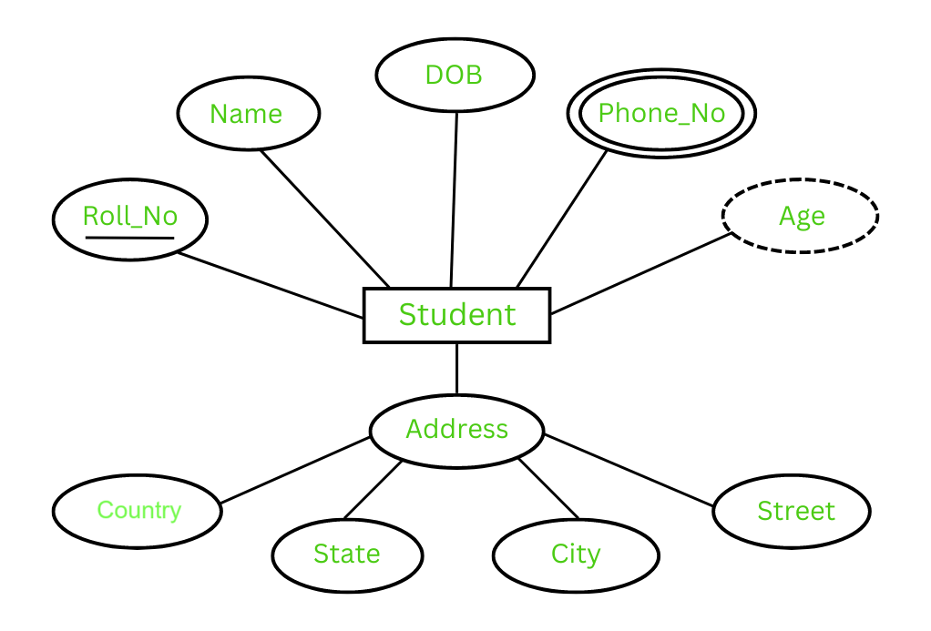

Types of Relationships

Type | Description | Example
One to One | One entity is related to one entity | A person has one passport
One to Many | One entity related to many others | One teacher teaches many students
Many to One | Many entities related to one | Many employees work in one department
Many to Many | Many entities related to many | Students enroll in many courses

Type 1: One-to-One Relationship
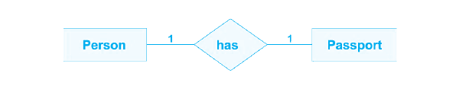
A one-to-one relationship occurs when each record in one entity is related to only one record in another entity, and vice versa. This type of relationship is relatively rare in databases, but it is essential in specific scenarios.

For example: If there are two entities, one is a ‘Person’ (Id, Name, Age, Address) and the other is a ‘Passport’ (Passport_id, Passport_no). As a result, each individual can only have one passport, and each passport can only belong to one person. For example: If there are two entities, one is a ‘Person’ (Id, Name, Age, Address) and the other is a ‘Passport’ (Passport_id, Passport_no). As a result, each individual can only have one passport, and each passport can only belong to one person.

Type 2: One-to-Many Relationship
The one-to-many relationship is the most common type of relationship in DBMS. In this relationship, a record in one entity can be associated with multiple records in another entity, while each record in the second entity is related to only one record in the first entity. For instance, in a customer and order database, each customer can place multiple orders, but each order is associated with only one customer.

For example: If there are two entity types ‘Customer’ and ‘Account’ then each ‘Customer’ can have more than one ‘Account’ but each ‘Account’ is owned by only one ‘Customer’. In this case, one Customer is connected with several Accounts. As a result, it is a one-to-many relationship. However, if we look at it another way, that multiple Accounts are connected with one Customer, we may claim that it is a many-to-one connection.

Type 3: Many-to-Many Relationship
A many-to-many relationship arises when multiple records in one entity can be linked to multiple records in another entity. To represent such relationships, a separate associative entity, often called a junction table or bridge table, is introduced. For example, in a database for students and courses, a many-to-many relationship exists, as each student can enroll in multiple courses, and each course can have multiple students.

Example: If there are two entity type ‘Customer’ and ‘Product’ then each customer can buy more than one product and a product can be bought by many different customers.

Example: ER Model for Student-Course Database

Scenario
We want to store data about:
- Students
- Courses
- Which student enrolled in which course

Entities and Attributes
Student
- Student_ID (Primary Key)
- Name
- Email
- Age
Course
- Course_ID (Primary Key)
- Course_Name
- Duration
Relationship: ENROLLS
- Student enrolls in Course
- Relationship has attribute: Date_Of_Enrollment

Tables Based on ER Model
Table: Student
Student_ID | Name | Email | Age
101 | John | john@gmail.com | 20

Table: Course
Course_ID | Course_Name | Duration
CSE101 | DBMS | 4 Months

Table: Enrolls
Student_ID | Course_ID | Date_Of_Enrollment
101 | CSE101 | 2025-06-20

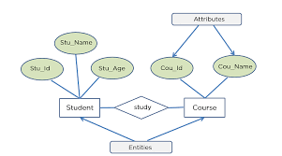

Assignment: Design an ER Diagram for a Library Management System

Objective:
Design an Entity-Relationship (ER) Diagram for a Library Management System that stores and manages information about books, members, and borrowing activities.

Scenario:
You have been hired to design a database system for a library. The library wants to manage:
- Books and their details
- Library members
- Which member borrows which books
- The date when a book is borrowed and returned

Requirements:
Based on the scenario, identify entities, their attributes, and relationships. Then, draw an ER Diagram representing the following:

🔹 Entities and Sample Attributes:
- Book
  - Book_ID (Primary Key)
  - Title
  - Author
  - ISBN (International Standard Book Number)
  - Publisher
- Member
  - Member_ID (Primary Key)
  - Name
  - Email
  - Phone_Number
  - Address
- Borrow
  - Relationship between Member and Book
  - Attributes: Borrow_Date, Return_Date

Relationships:
- A Member can borrow many books
- A Book can be borrowed by many members over time (many-to-many)
- The Borrow relationship includes Borrow_Date and Return_Date

