Microsoft Word

Module 40 – Create Label and Envelope in MS Word

What is Label?
In MS Word, a label is used to print the same or different text, like names or addresses, on sticker sheets. You can find the Labels option under the Mailings tab. It helps you create address labels, name tags, or product price tags. You can type one label or use a list from Excel to print many different labels at once using Mail Merge. Labels are useful when you want to print information neatly on multiple stickers quickly.
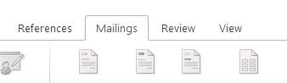
Steps to Create Label in MS Word:
- Open MS Word on your computer.
- Click on the Mailings tab at the top.

- Click on Labels in the “Create” group.
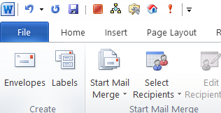
- In the box that appears, type the text you want on the label.
- Click on Options to choose your label size and brand.
- Click OK, and then click New Document to see your labels on a page.
- You can now print the labels or add more details if needed.

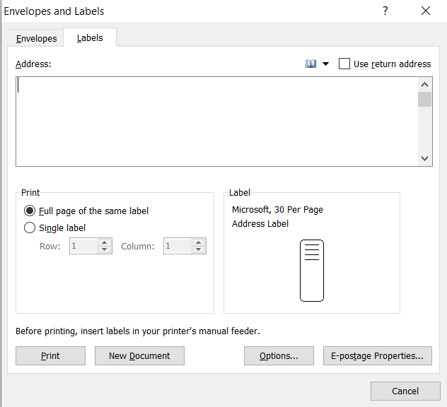

What is Envelope in MS Word?

In MS Word, an envelope is a feature that helps you create and print mailing envelopes with addresses. You can type the recipient's address and your return address, and Word will place them in the correct positions on the envelope. This feature is found in the Mailings tab under Envelopes. You can also choose the envelope size and layout, and even connect to an Excel sheet to print many envelopes using Mail Merge. It saves time and ensures that your envelopes look neat and professional.
Steps to Create Envelope in MS Word:
- Open MS Word on your computer.
- Click on the Mailings tab at the top.

- Click on Envelopes in the “Create” group.
- In the box that appears, type the Delivery Address (receiver’s address).
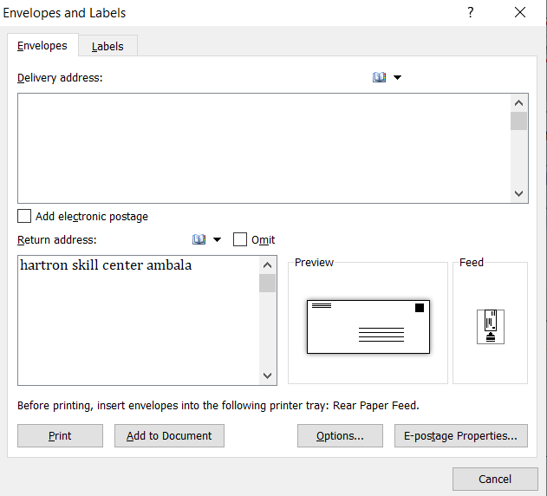

- Type the Return Address (your address).
- Click on Options to choose the envelope size and printer settings.

- Click Add to Document to see the envelope on the page.

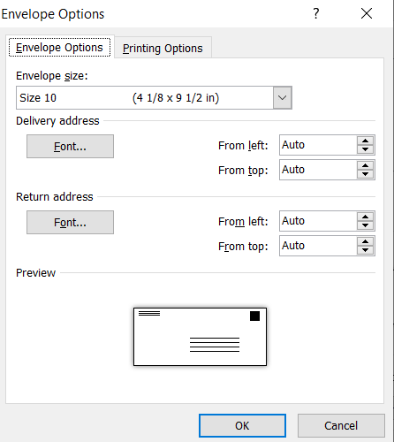
Finally, click Print to print the envelope directly.

